Sierra College MECH-01
Jim Weir 530.272.2203
jweir@sierracollege.edu
www.rstengineering.com/sierra

Application 10

- Compiling, Programming, and Executing

- Compiling the Program

- Open Microcode Studio.

- Open a New program file. Take the preset header (with all the asterisks (*) around it off.

- Cut and paste the program from “Theory” into Studio (see next page).

- Rename the program something you will remember

- Save the program anywhere you like on the hard disk, but SAVE IT TO YOUR FLASH DRIVE as well. Be sure to save it as a .bas file and not a .pgp or other suffix file. Note that at the end of class, the hard disk copy will be erased.

- Exit Studio

- Reopen studio and open your program FROM YOUR FLASH DRIVE

- Look the program over to be sure that it is the one you “wrote” or pasted.

- Compile the program with the Compile Program command.

- If the program shows errors, fix the errors. Otherwise, the program should show “Compile Successful No Errors.

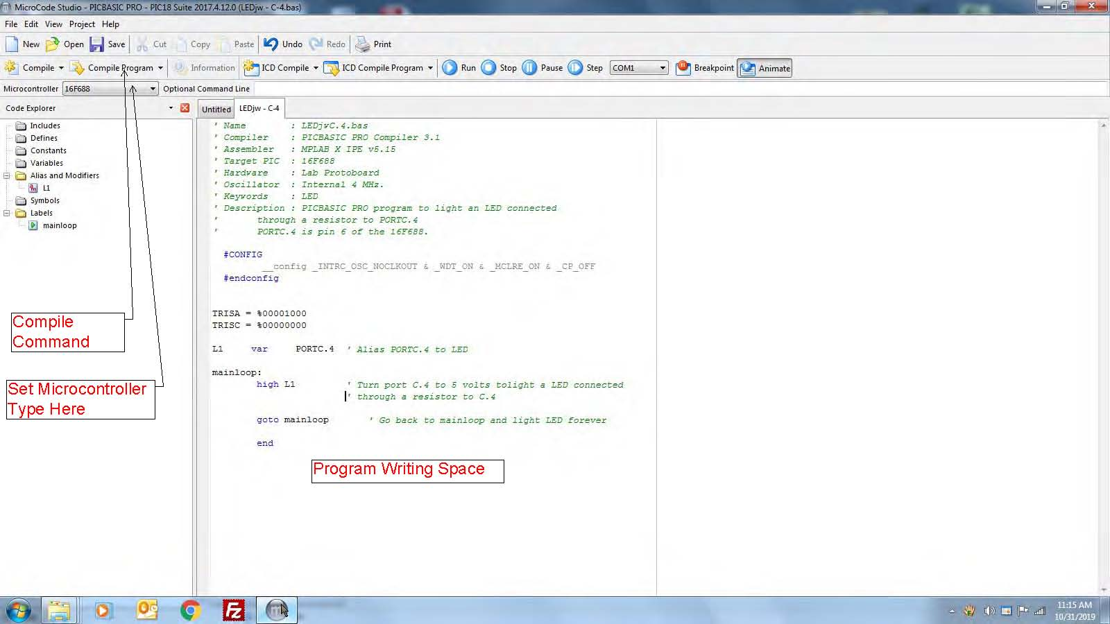
- Your flash drive should have the following files on it (this is mine, yours should have your initials on it):
- Your hex file will look something like this:
:020000040000FA
:10000000012883160830850087018312071683169E
:0E001000071283128A01062863008A010C2859
:02400E00FC3F75
:00000001FF

- Take your BASIC .bas file and your Compiled .hex file to the instructor for programming.
.
- Using a trainer, construct the circuit in “LED Test” below. You may use a dummy or scrap 14 pin to lay out the connections before installing the actual microcontroller chip. Test the LED, and then see if pin 6 of the microcontroller lights the light. Put the free end of the resistor on any pin but 1 and 6 to see if any of the other pins are HIGH (+5 volts). No other pin should light the LED

.